# Reproducibility Check

This document should guide any user to running the simulation of a sneaker resale market. The project’s results can all be recreated using the MATLAB file “Financial_Market.m”. Users will need an up to date version of MATLAB to run the script. The user can use their own inputs and follow the ones from the project report.

## Light Test

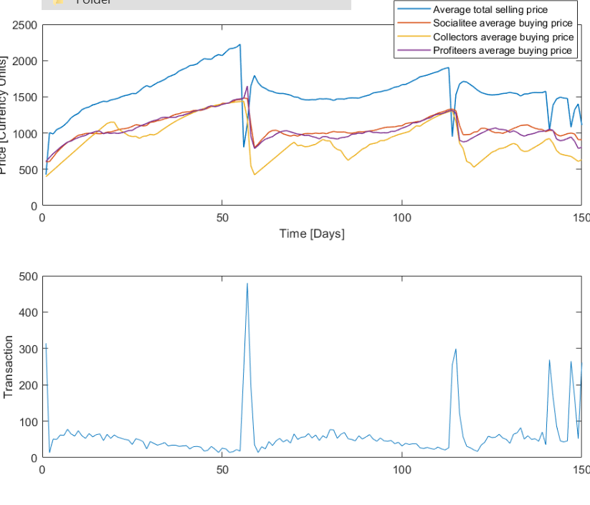The user will be reproducing Figure 5 a from the report, reproduced here below. They simply need to open the MATLAB file “Financial_Market.m” from the folder in the git and run it with the following inputs:

n_agents : 1000

n_items : 200

price : 700

nbrands : 4

rndbrand : 1

timesteps : 150

Figure 5 a) Average buying prices from the different buyers and global average price. Bottom: Number of transactions each day.